EC-231 Operating Systems
BS(CE)-2021
LAB REPORT # 9

Submitted By:
Reg. No. | Name
21-CE-009 | Huzaifa Shahbaz
21-CE-020 | Muhammad Ibthesam
21-CE-021 | Yawar Ali Malik
Department of Computer Engineering
BS Computer Engineering Program
HITEC University Taxila
 | Presentation  (Format (0.5) + Title (0.5) +  Conclusion(1) + Procedure(2) + Objective(1)) | Calculation/Coding | Observation/ Program Results | Total
Total | 5 | 5 | 5 | 15
Obtained

___________________________
Lab Instructor.
Engr. Fasih Ahmad
Experiment #9
File Structure related System Calls in Linux
Objective: In this lab we will learn about system call techniques in LINUX.

Software Used: 1.Virtual box 2.Ubuntu 3.Sublime text editor 4.GCC COMPLIER

Procedure: System Call: A system call is just what its name implies, a request for the operating system to do something on behalf of the users’ program. Process related system calls: 1. fork() 2.wait() 3. exec() 4. exit() Basically there are total 5 types of I/O or File Structure system calls: 1. create() 2. open() 3. close() 4. read() 5. write() Create: Used to create a new empty file. Syntax in C language: int creat(char *filename, mode_t mode) Parameter: 1.filename is a name of the file which you want to create 2. mode is a indicates permissions of new file. Returns: 1. return first unused file descriptor (generally 3 when first creat use in process because 0, 1, 2 fd are reserved) 2. return -1 when error How it work in OS: 1. Create new empty file on disk 2. Create file table entry 3. Set first unused file descriptor to point to file table entry 4.Return file descriptor used, -1 upon failure Open: Used to Open the file for reading, writing or both. Syntax in C language: #include<sys/types.h> #include<sys/stat.h> #include <fcntl.h> int open (const char* Path, int flags [, int mode ]); Parameters: 1. Path is to file which you want to use 2. use absolute path begin with “/”, when you are not work in same directory of file. 3. Use relative path which is only file name with extension, when you are work in same directory of file. 4.flags is How you like to use 5. O_RDONLY: read only, O_WRONLY: write only, O_RDWR: read and write, O_CREAT: create file if it doesn’t exist, O_EXCL: prevent creation if it already exists How it works in OS: 1.Find existing file on disk 2. Create file table entry 3. Set first unused file descriptor to point to file table entry 4. Return file descriptor used, -1 upon failure Close: Tells the operating system you are done with a file descriptor and Close the file which pointed by fd. Syntax in C language: #include <fcntl.h> int close(int fd); Parameter: fd stands for file descriptor Return 1. 0 on success. 2. -1 on error. How it works in the OS: 1.Destroy file table entry referenced by element fd of file descriptor table – As long as no other process is pointing to it! 2. Set element fd of file descriptor table to NULL Read: From the file indicated by the file descriptor fd, the read() function reads cnt bytes of input into the memory area indicated by buf. A successful read() updates the access time for the file. Syntax in C language: size_t read (int fd, void* buf, size_t cnt);
Parameters: 1.file descriptor 2. buf: buffer to read data from 3. cnt: length of buffer Returns: How many bytes were actually read 1. return Number of bytes read on success 2. return 0 on reaching end of file 3. return -1 on error 4. return -1 on signal interrupt Important points: 1. buf needs to point to a valid memory location with length not smaller than the specified size because of overflow.
• fd should be a valid file descriptor returned from open() to perform read operation because
if fd is NULL then read should generate error.
• cnt is the requested number of bytes read, while the return value is the actual number of
bytes read. Also, sometimes read system call should read less bytes than cnt.-(Use Times New Roman 12)

Tasks
Task 1: (a)Simulate suitable command/commands in gedit editor to open a file which should have permission of writing only. Now write five city names in the file. And add screenshot of .txt file in your lab report. 1(b). Simulate suitable command/commands in gedit editor to open a file which should have permission of reading only. Now read above written city names from the file. And show contents in the output. CODE: 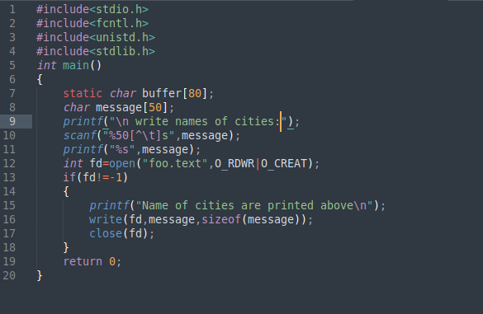
FILE: 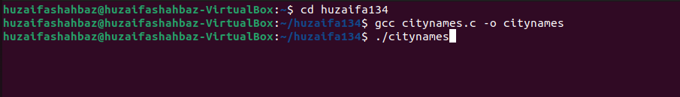 OUTPUT: 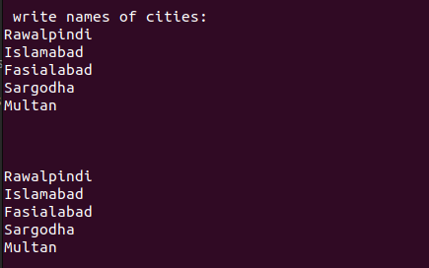
Task 2: Simulate suitable command/commands in gedit editor to write your introduction i.e. name, father’s name, registration number and class in the file and after that read those characters from file and save it into a variable. Display the contents of variable i.e. data read from the file. CODE: 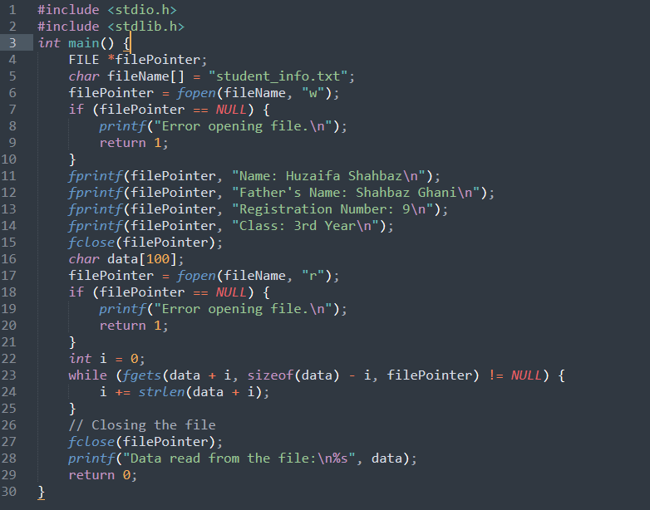 File: OUTPUT: 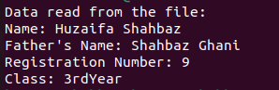
Conclusion: In conclusion, linux system calls related to file structures offer fundamental features for file and directory management. Processes can effectively create, open, read, write, and manipulate files and directories with the help of these system calls. They serve as an essential conduit between user-space programs and the kernel, enabling smooth file operations. Linux provides a strong foundation for managing and retrieving data from the filesystem using these methods. All things considered, system calls pertaining to file structures enable programmers to create robust and adaptable Linux programs.

